Revised 03/01/17
SPECIFICATION
Section 12495 ISC6000 – 7000 Motorized Roller Shades
Division 12

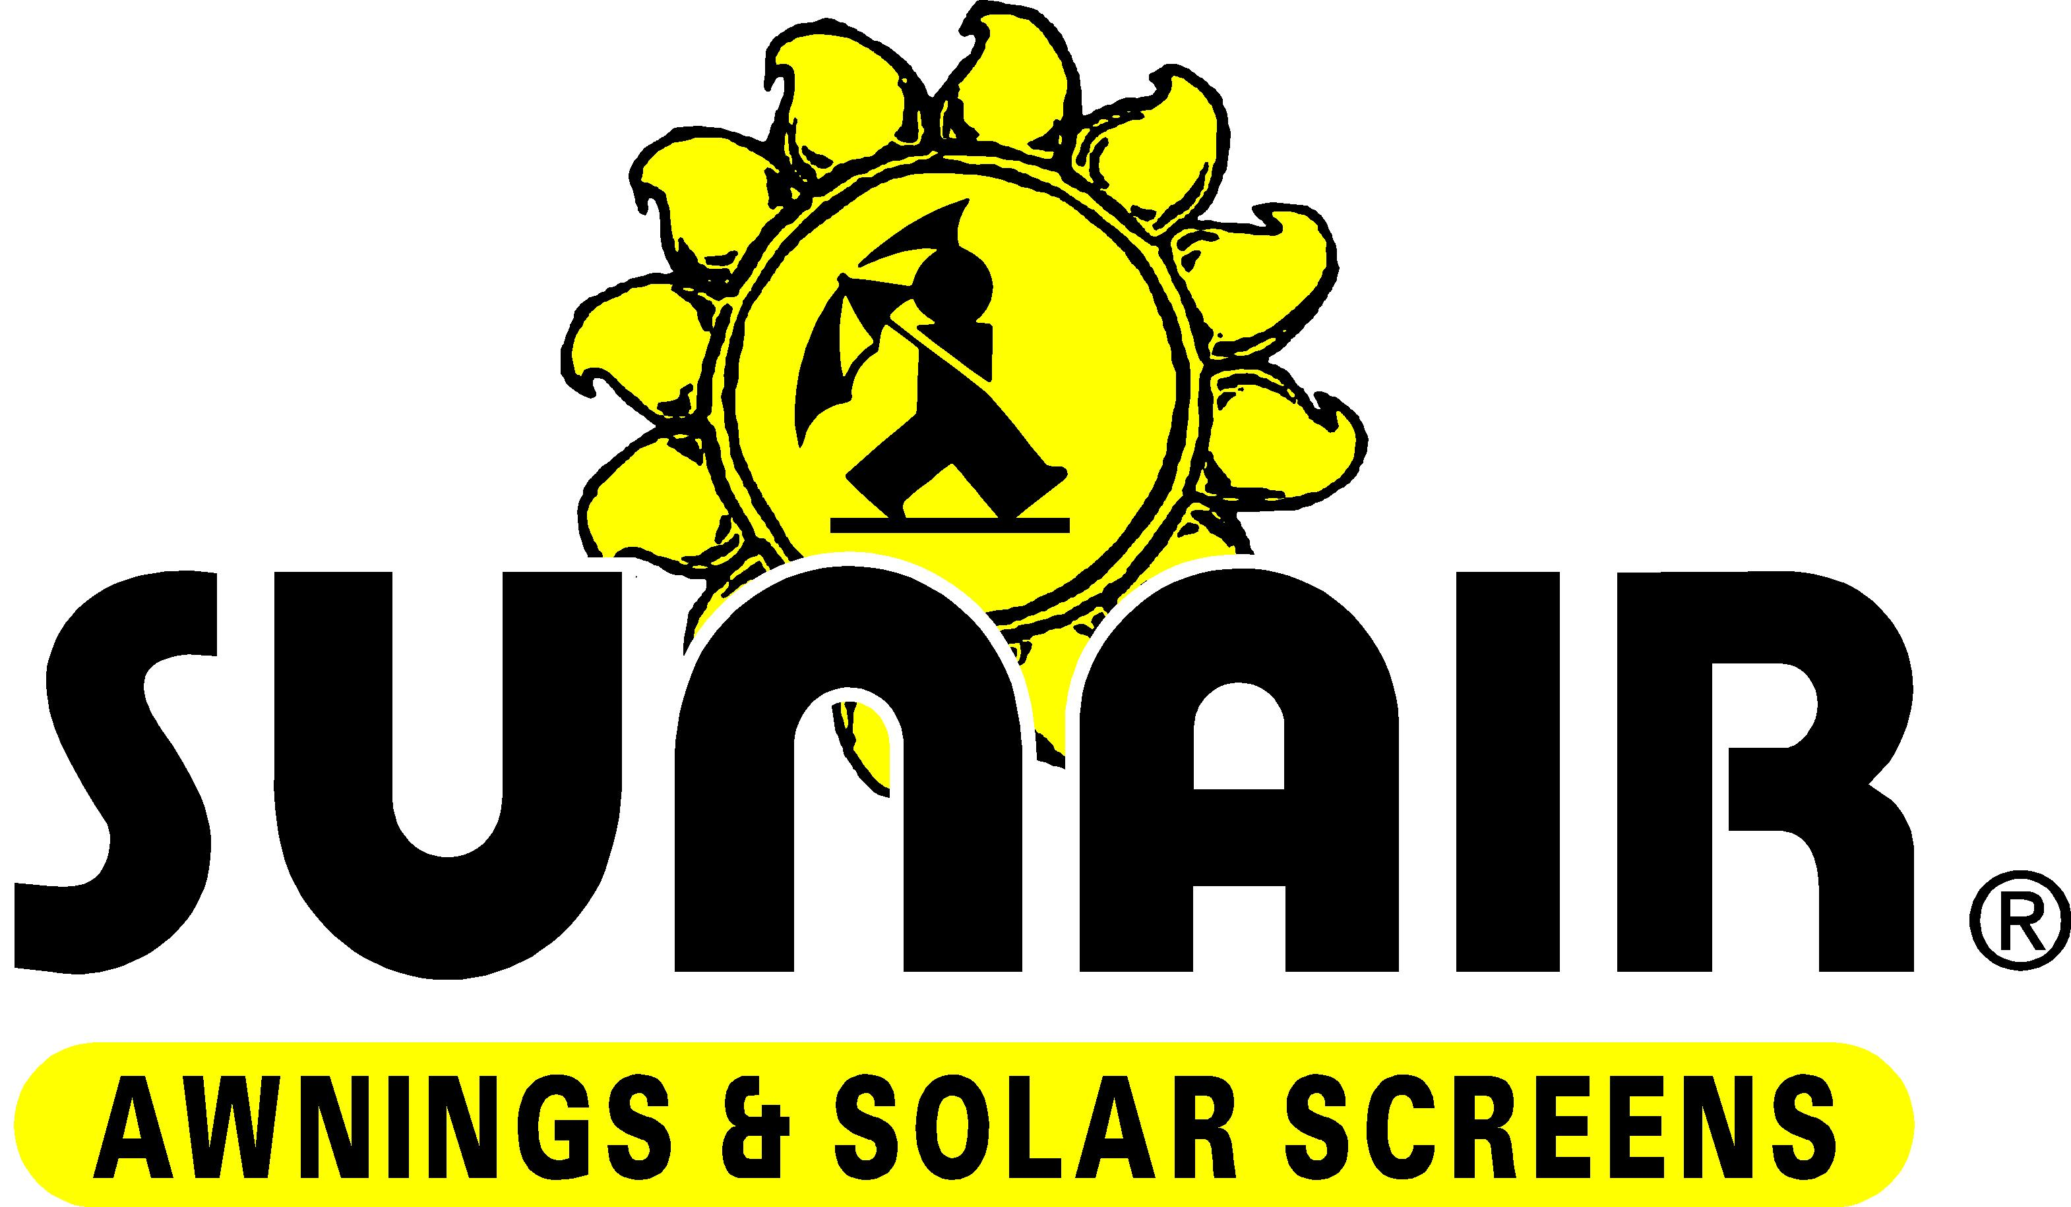

P.O. Box 1068 7785 Rt. 175,
Jessup, MD 20794

JESSUP, MD 800 – 548 – 0408
PHOENIX, AZ 877 – 272 - 3920

Specifications for ISC6000, 6500, and 7000 motorized operated Roller Shades:

PART 1 - GENERAL

  - SCOPE / DESCRIPTION

- Furnish and install motorized roller shade(s) as manufactured by Sunair Awnings & Solar screens, P.O Box 1068, 7785 Rt. 175, Jessup, MD 20795 in accordance with the specifications below.

  - SUBMITTALS

- Product Data: Manufacturers data sheet shall be submitted for each product specified including finishes, dimensions, options and installation instructions.

B. Drawings and diagrams: Product details, installation details,
working and assembly drawings shall be supplied as requested.

- Sample: Contractor or agent shall supply samples as required.

QUALITY ASSURANCE

A. Product shall be manufactured to meet or exceed the quality
and standards of the SUNAIR® product as per description above.

B. Supplier shall be approved to supply the products specified and
shall honor all claims and warranties as specified in accordance
with warranty.

SUNAIR® AWNINGS & SOLAR SCREENS P.O Box 1068 Jessup, MD 20794
Phone: 410-799-1145 1-800-548-0408 Fax: 410-799-5584 www.sunairawnings.com Info@sunairawnings.com

- Provide shades from one manufacturer for the entire project.

DELIVERY STORAGE AND HANDLING

A. Product shall be delivered to site in manufacturer original
packaging.

B. All products should be stored and handled to prevent damage to
materials, finishes, and operating mechanism.

WARRANTY

- Manufacturer shall honor product warranty from date of installation (See specific warranty detail available from SUNAIR® Awnings & Solar Screens).

PART 2 – PRODUCT

2.1 ROLLER SHADES

Acceptable products: ISC6000, ISC6500, ISC6600, and ISC7000, as manufactured by: East Coast: SUNAIR® Awnings and Solar Screens (Awnings Unlimited Inc) P.O Box 1068, 7785 Rt. 175, Jessup, MD 20794. 800–548-0408. West Coast: SUNAIR® West 3803 West Thomas Rd, Phoenix AZ 877-272-3920.

- Shade Band Material / Fabric: Roller Shade fabric shall be inherently flame retardant, fade and stain resistant, anti-static, anti microbial light filtering, room darkening or “black out “ providing 0 – 15% openness factors. The fabric shall pass NFPA 701-99 Test 1. Bottom hem shall be ultrasonically welded with either internal or external hem bar. Shades that have railroaded fabric may have horizontal heat welded seams. Fabric will be selected by architect from the SUNAIR standard fabric collection.

- Tubing: The roller tube will range between 1 ½” to 2 ½” to be compatible with selected range sizes. The tubing shall be manufactured from 6063 T5 aluminum with sufficient thickness to prevent excessive deflection.

- Direction of Roll: back of roller is regular, reverse roll is available and can be specified.

SUNAIR® AWNINGS & SOLAR SCREENS P.O Box 1068 Jessup, MD 20794
Phone: 410-799-1145 1-800-548-0408 Fax: 410-799-5584 www.sunairawnings.com Info@sunairawnings.com

- Bottom / Hem bar: To be extruded aluminum either; Standard bottom bar with internal extruded aluminum bar with sealed ends or optional external bottom bar extruded and powder coated color to match hardware brackets and accessories.

- Mounting brackets: Shall be steel powder coated to match hardware and allow removal of the roller tube assembly without removing the brackets.

- Shade operation: Motorized; with motors and controls by Somfy Systems inc (Cranberry, NJ). Motors shall be either AC line voltage motors, DC motors, or both, utilizing Somfy control systems.

- Any substitutions must be submitted for approval 30 days prior to close of bid.

  - ROLLER SHADE FABRICATION

A. Field measure and verify sizes prior to manufacturing after all
other work has been completed.

Make sure the shade fits from top to bottom of window and that the edge of the bracket is no more than ¼” from the face of the jambs.

ROLLER SHADE FABRICATION

  - MOTORIZED OPERATORS

A. AC line voltage motors; Tubular, asynchronous motor, built-in
reverse capacitor, brushless, 110v AC ( 60 Hz) single phase
motor, thermally protected, permanently lubricated. Minimum of
4nm with sufficient lifting capacity to not need assistance by
other devices. Optional: ILT Intelligent AC motors; with multiple
pre-set intermediate positions, interface with SDN (Somfy
Digital Network).

B. DC LOW Voltage 24V SONNESSE 30 motors; Tubular motor,
thermally protected, permanently lubricated. Minimum of 2nm
with sufficient lifting capacity to not need assistance by
other devices. Powered by transformer (Single motor – 20
motors). Optional: ILT Intelligent DC motors; with multiple
pre-set intermediate positions, interface with SDN (Somfy
Digital Network).

SUNAIR® AWNINGS & SOLAR SCREENS P.O Box 1068 Jessup, MD 20794
Phone: 410-799-1145 1-800-548-0408 Fax: 410-799-5584 www.sunairawnings.com Info@sunairawnings.com

  - OPERATOR CONTROLS

A. RTS radio controls with wire free wall switches (Decoflex type)
or (Telis type) hand held remotes, or tied desktop network.

- Sun control, predictive solar scheduling and sun sensors.

- Wired modular network wall switches.

  - ACCESSORIES

  - Dual Roller Shades: Universal mount steel brackets with 2 separate rollers working independently from each other (Solar shade and room darkening black out).

  - Bottom Bar / Hem bar: Either Std Hem / Bottom bar with internal extruded aluminum bar with sealed ends, or optional external bottom bar extruded and powder coated color to match hardware brackets and accessories

  - Fascia: L shaped removable aluminum extrusion valance that attaches to the brackets and conceals the roller tube. Color will match other hardware and will be powder coated. 3” and 4” fascia as specified on all shades up to 9 ft high, and 4” fascia as specified on all shades taller than 9 ft. Standard flat / square fascia or optional rounded fascia. 7” fascia as is specified on Duo shades ISC6500 & ISC6600.

  - Black out tracks as specified on room darkening and black out shades. Powder coated aluminum to match hardware color.

  - Cassette 3” and 4” to enclose standard shade roller, as specified on ISC6000 and ISC7000 shades.

SUNAIR® AWNINGS & SOLAR SCREENS P.O Box 1068 Jessup, MD 20794
Phone: 410-799-1145 1-800-548-0408 Fax: 410-799-5584 www.sunairawnings.com Info@sunairawnings.com

PART 3 –EXECUTION

INSTALLATION

A. Install shades level and plumb, and align with adjacent units
if necessary.

Adjust roller shade to operate smoothly

  - DEMONSTRATION

A. Demonstrate operational method and instruct owner’s personnel
in proper operation and maintenance of the shade.

END OF SECTION

SUNAIR® AWNINGS & SOLAR SCREENS P.O Box 1068 Jessup, MD 20794
Phone: 410-799-1145 1-800-548-0408 Fax: 410-799-5584 www.sunairawnings.com Info@sunairawnings.com

